ProjectTitle:IOT Based Smart Crop Protection System for

Agriculture

Project DesignPhase-I.SolutionFit TeamID:PNT2022TMID17792

* Farmers who trying to protect crops •Limited supervision. •Automation in irrigation.

from various problems •Limited financial constrains. •CCTVcamera tomonitor andnsupervise

* + Lack of manpower. thebcrops.
    - Alarmnsystem to give alert while animals attacks the crops.
* Cropsarenotirrigatedproperly. •Due to in sufficient labourforces. •Asks suggestions from surrounding

# Improper maintenance of crops.

* Lack of knowledge among farmers inusage offertilizers and hence crops are affected.

# •

Due to various environmental factors such as temperature climate,to pography and soilquality which results incrop destruction.

peoples and implement there cent technologies.

* Consumes more time in cropland.
* Searching for an alternative solution for
* Requires protecting crops from Wild •Due to high ammonia,urea, anexistingsolution.

# animals attacks,birds and pests. potassium and highPHlevelfertilizers.

* By seeing surrounding cropland with • Moisture sensor interfaced withArduinoMicrocontroller to • Usingdifferentplatforms/socialmedia

measure the moisture level in soil and relay isused toturn ON and OFF the motorpump for managing the excess water level.

installing machineries.

to describe th eworking and uses of

* Hearing aboutinnovativetechnologies It will be updated to authorities through IOT. smart crop protection device. andeffective solutions. • Temperature sensor connected to microcontroller isused to

monitor the temperature inthe field. The optimum temperature required for crop cultivation is maintained using

.

* Mentalfrustrations due to insufficient production of crops.

IOT basedfertilizingmethodsare followed,to minimize the

negative effects on growth of crops while using fertilizers .

Giving awarenes among farmers about the application of the device.

* Felt smart enough to follow the available • Image processing techniques with IOT isfollowed forcrop

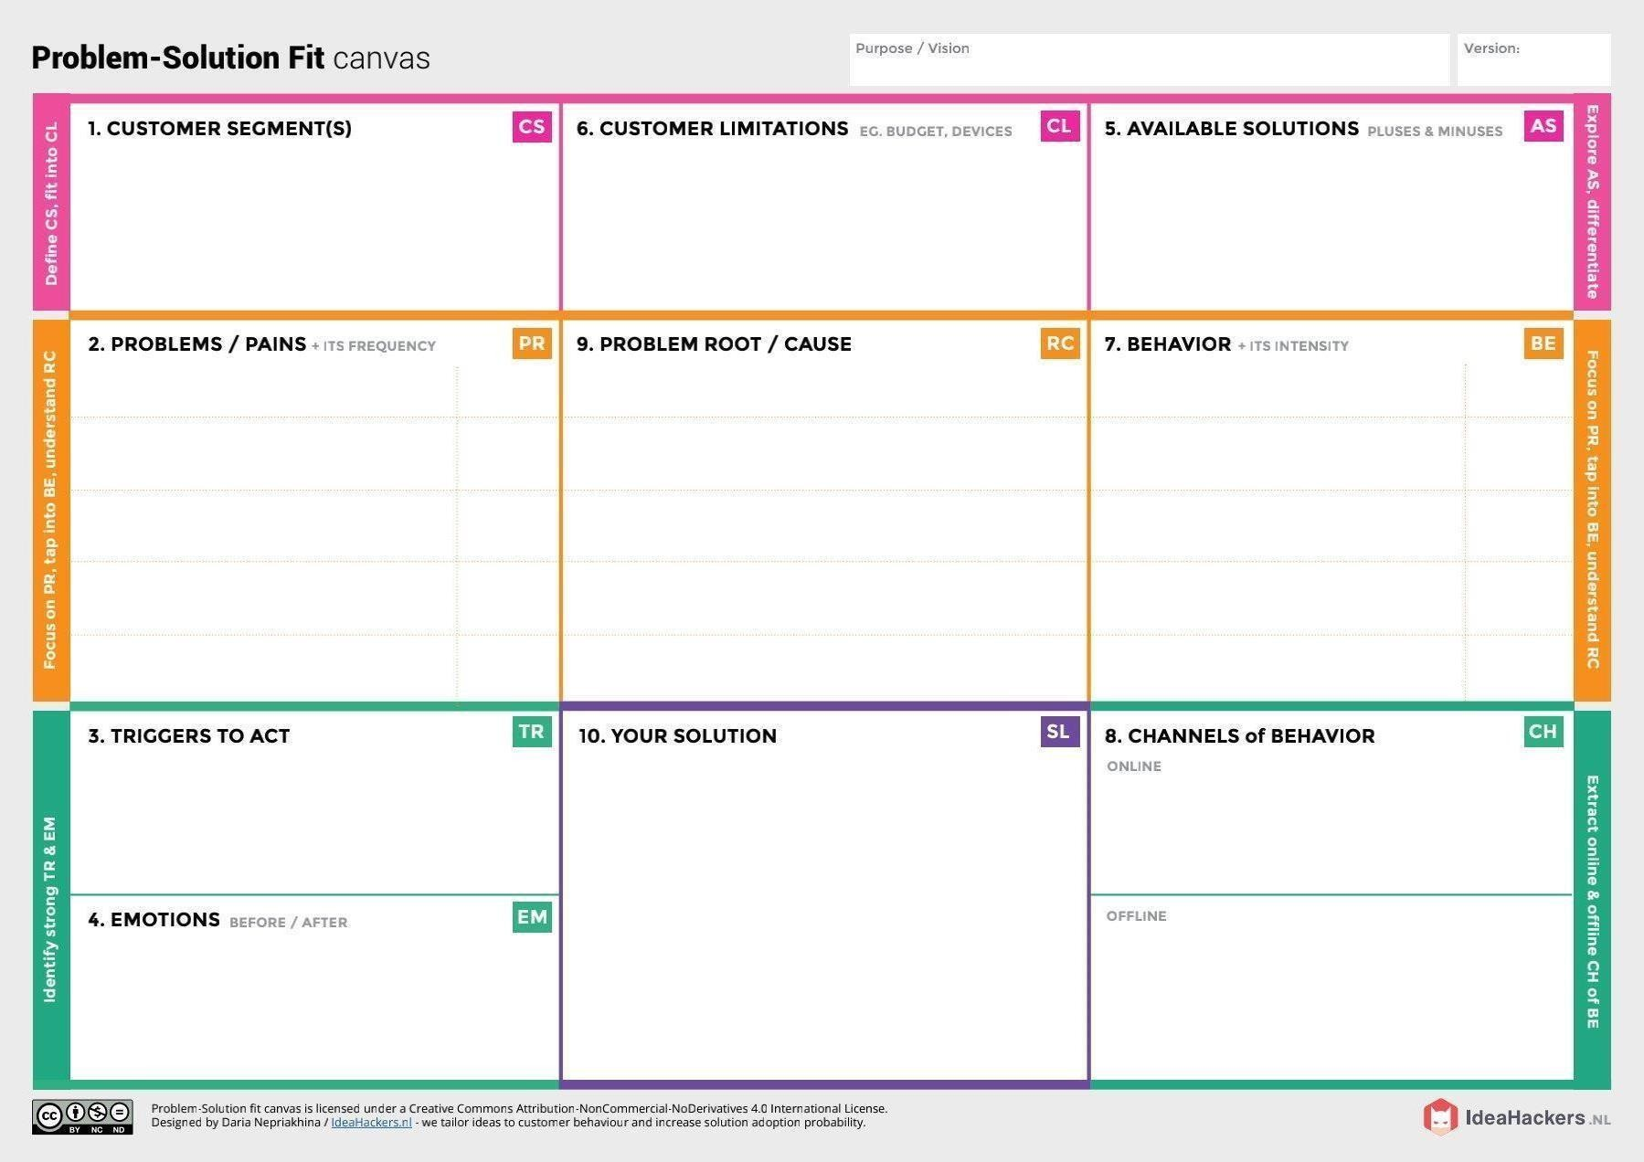

technologies with minimum cost. protection agains animalattacks.